* Prectical Tast ( Staff Management ):

Run the following command :

* Composer install or composer update.
* Php artisan migrate .
* Php artisan db:seed –class=AdminSeeder.
* composer require laravel/passport
* php artisan migrate
* php artisan passport:install
* Admin Login :

Email: [admin@gmail.com](mailto:admin@gmail.com)

Password: password

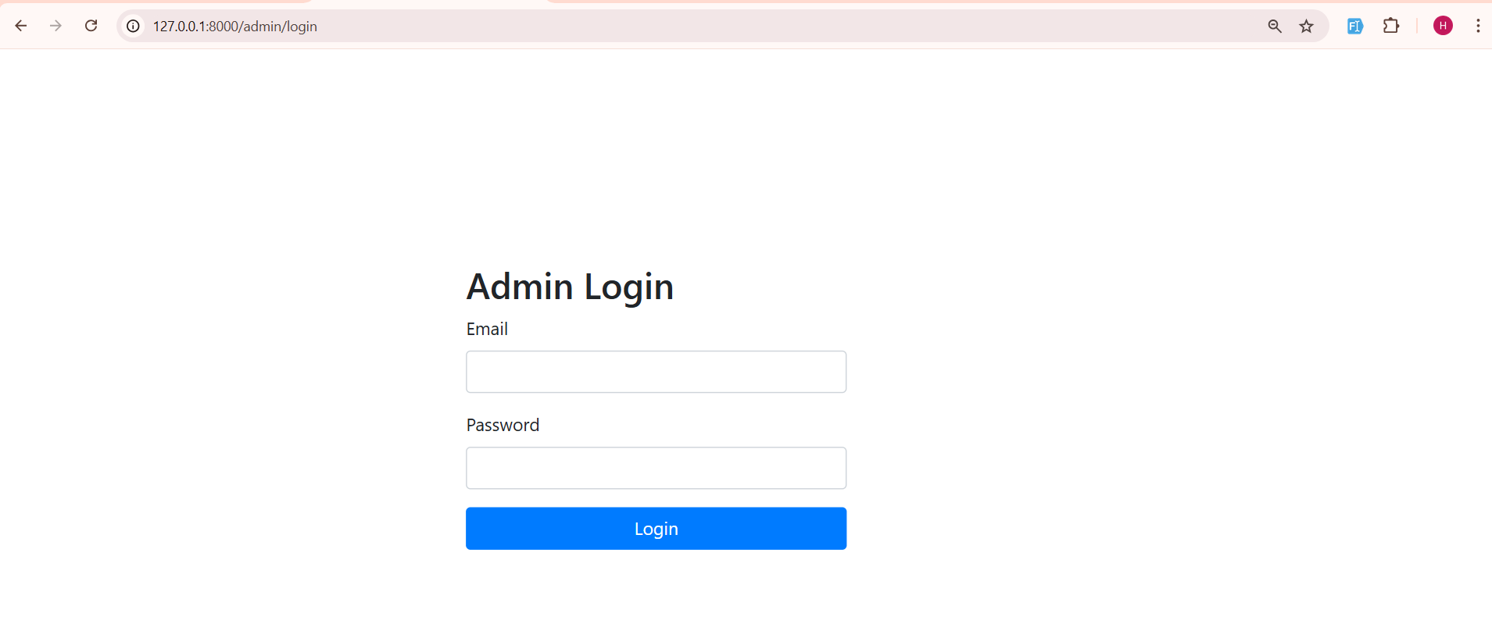

* Admin side Dashboard:

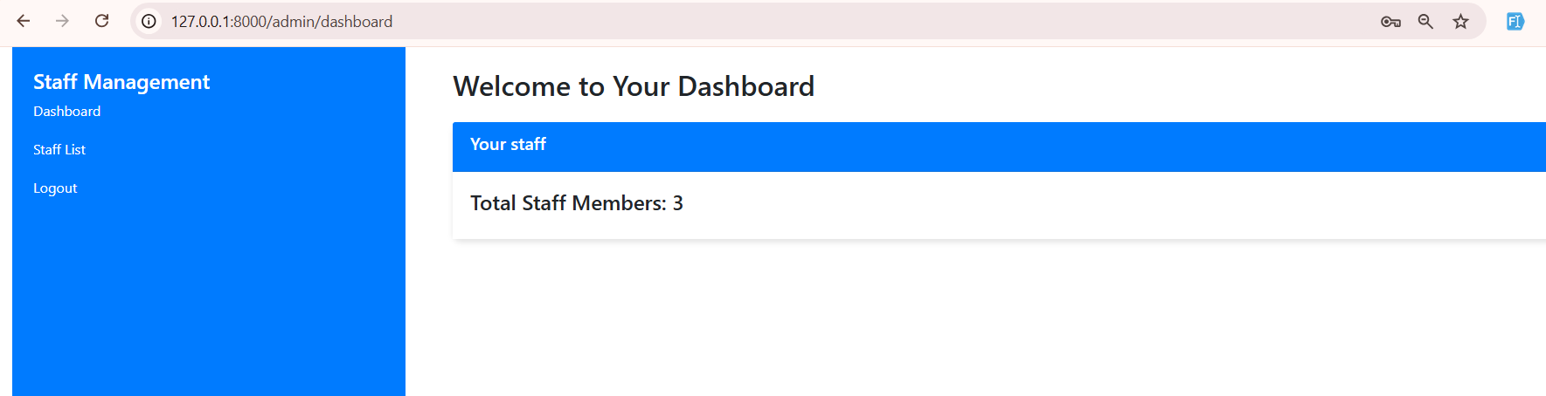

* Staff listing :

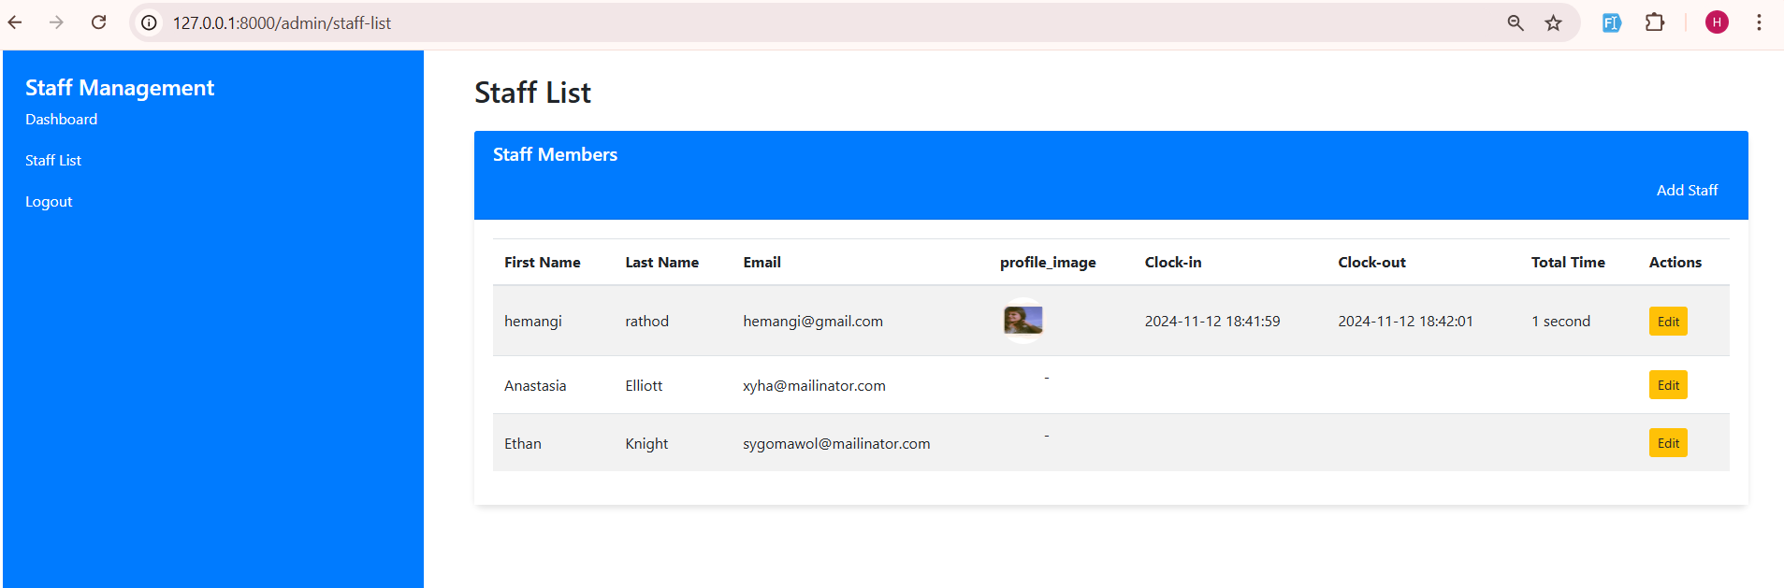

* Add Staff :

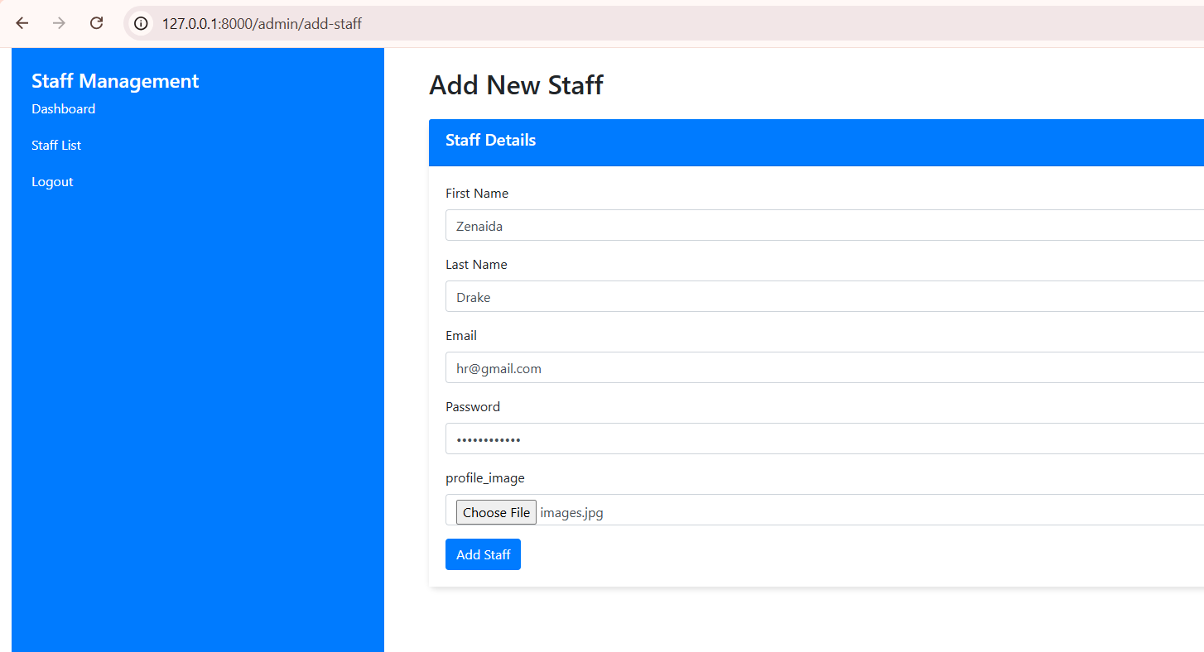

* Edit staff:

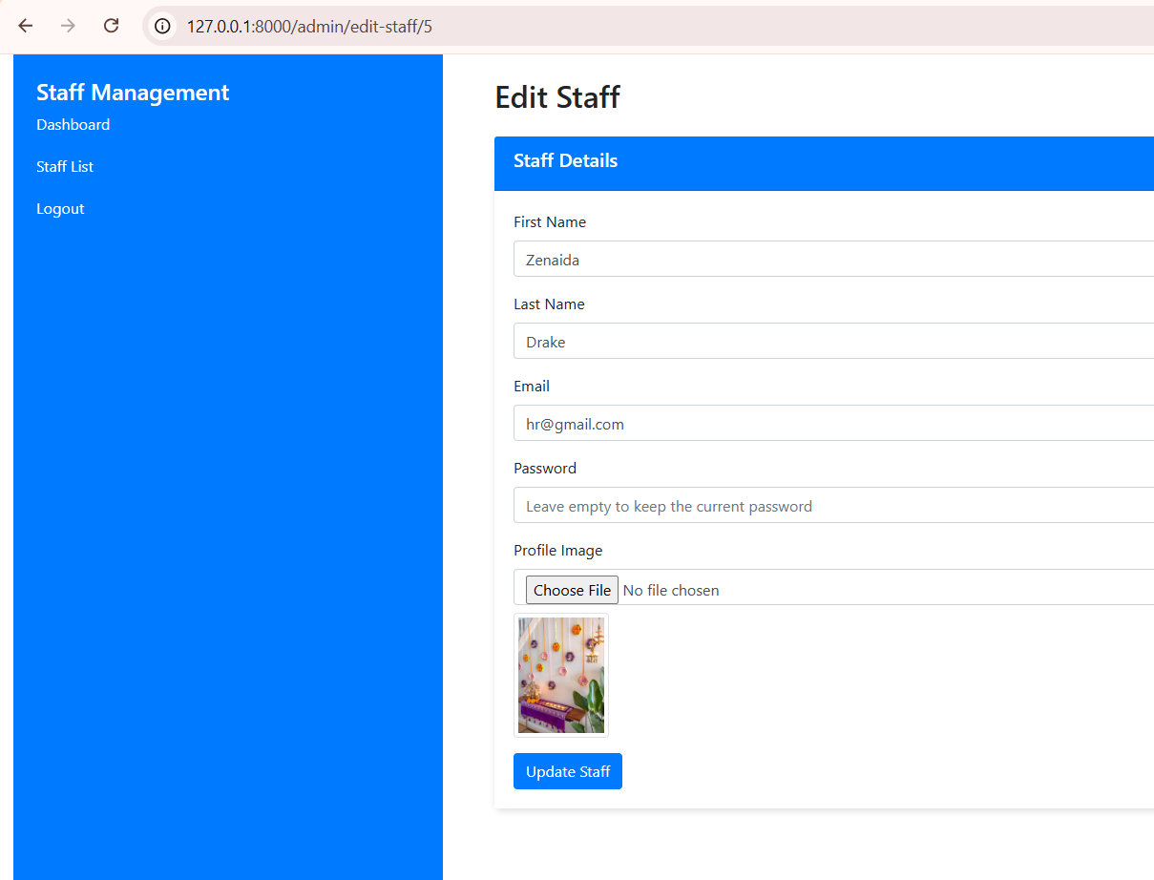

* Valiations :

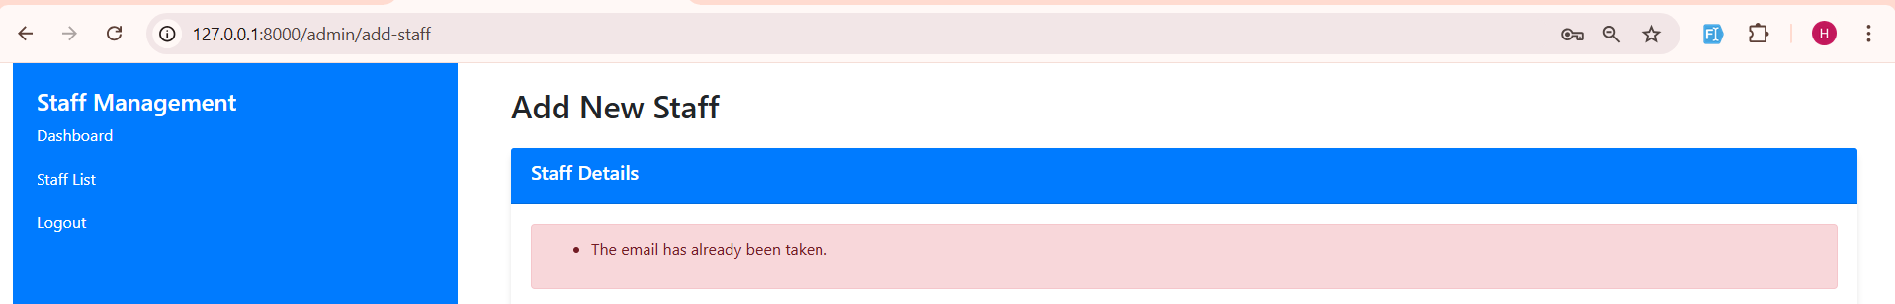

* Staff Add time mail send to that staff:

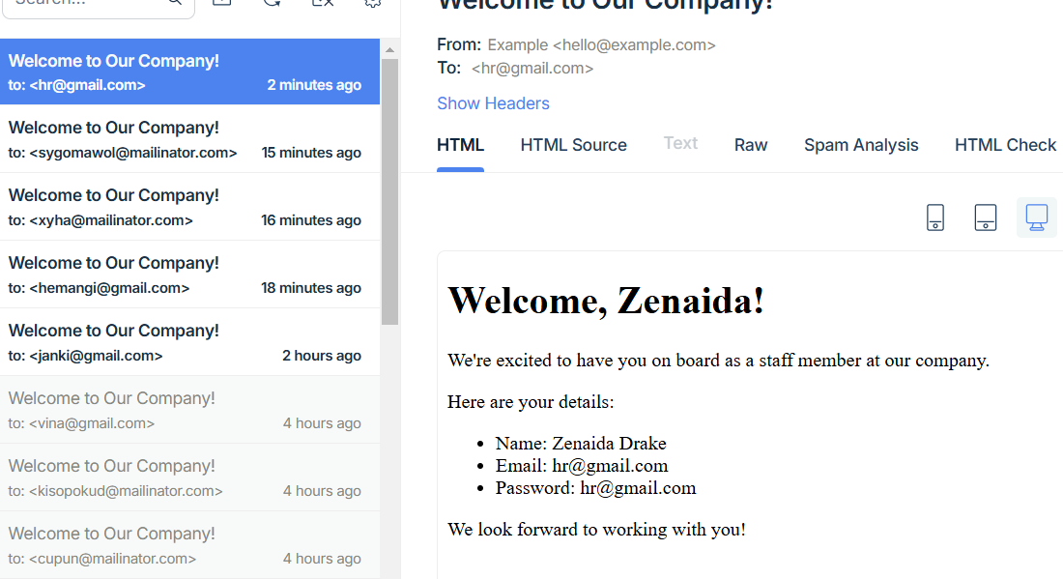

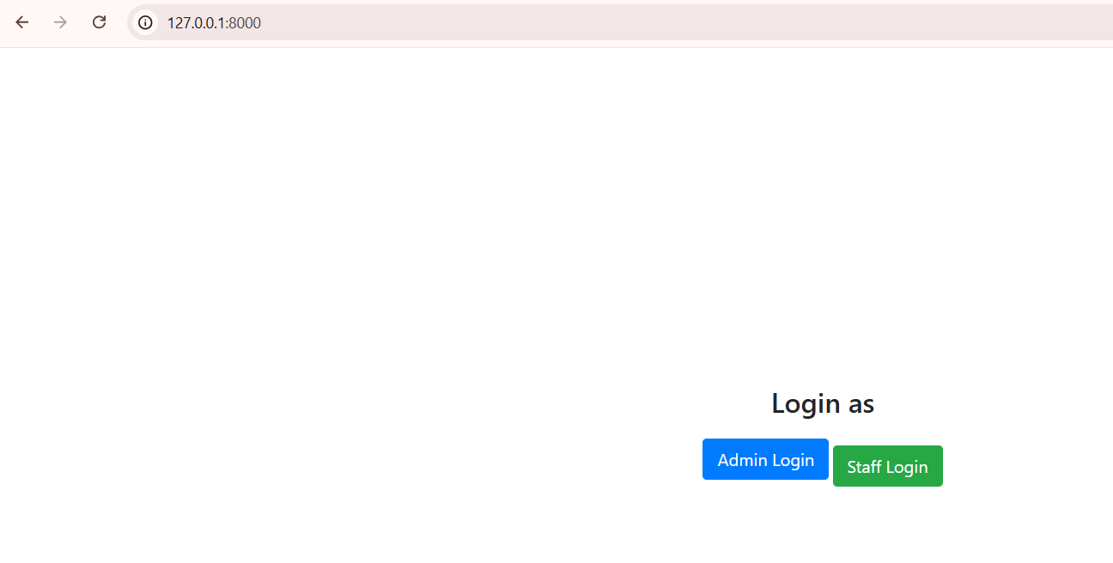

* Staff Register and login:

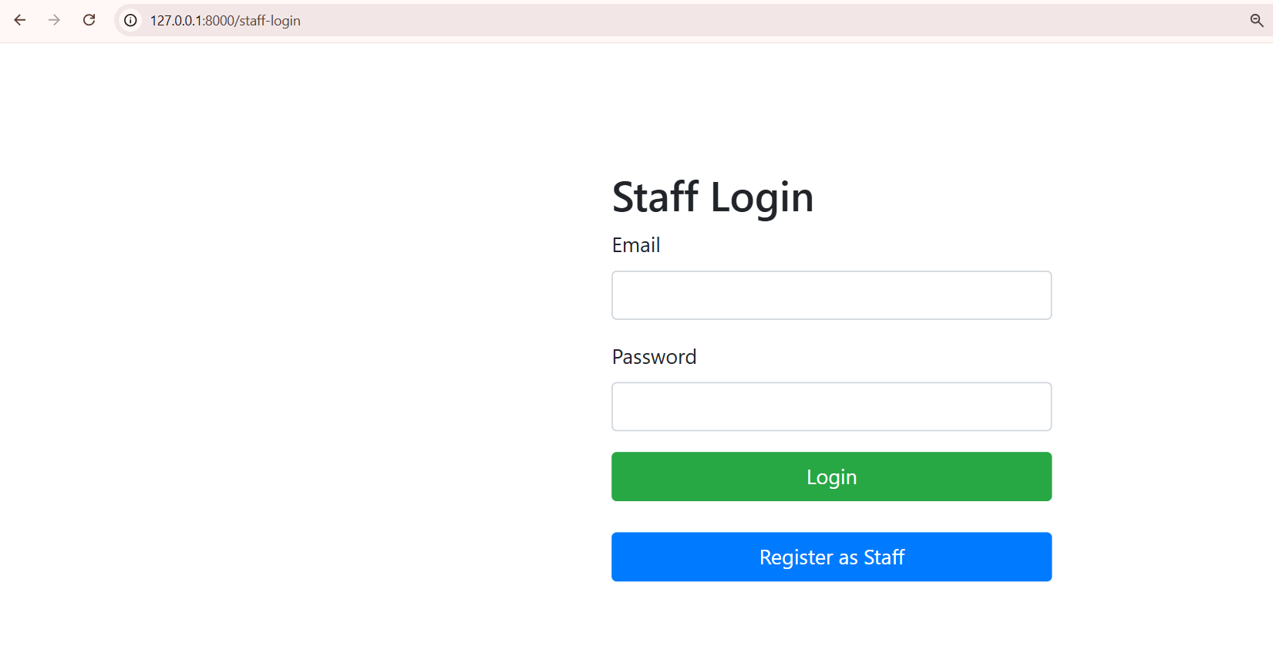

* Staff dashboard:

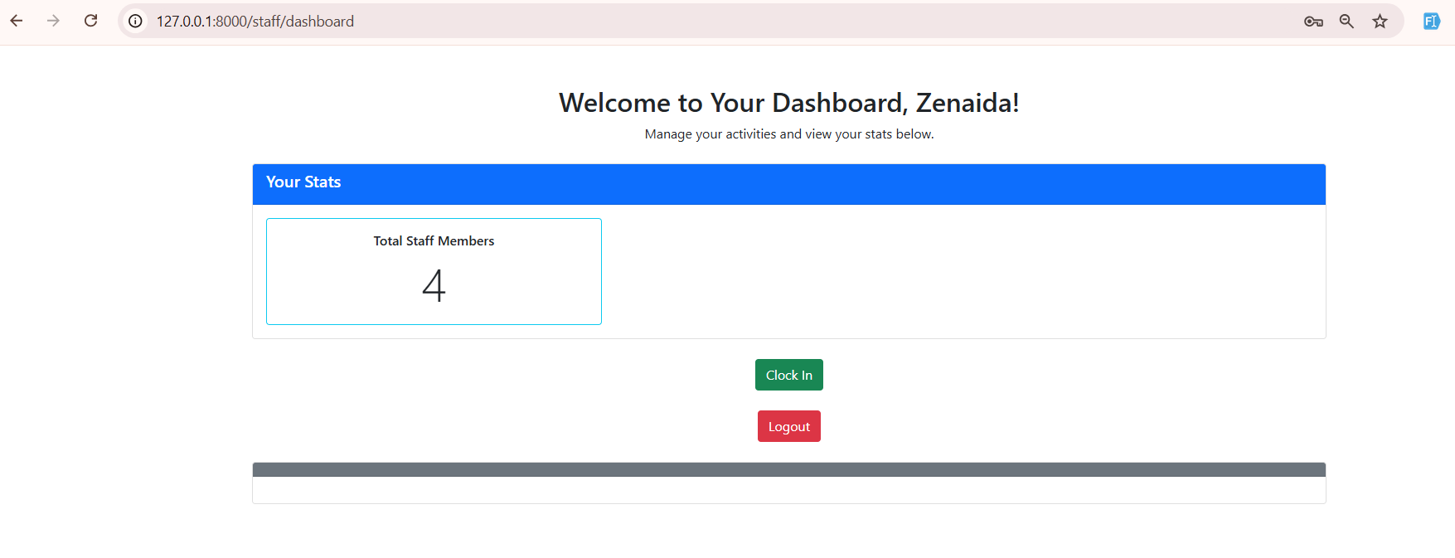

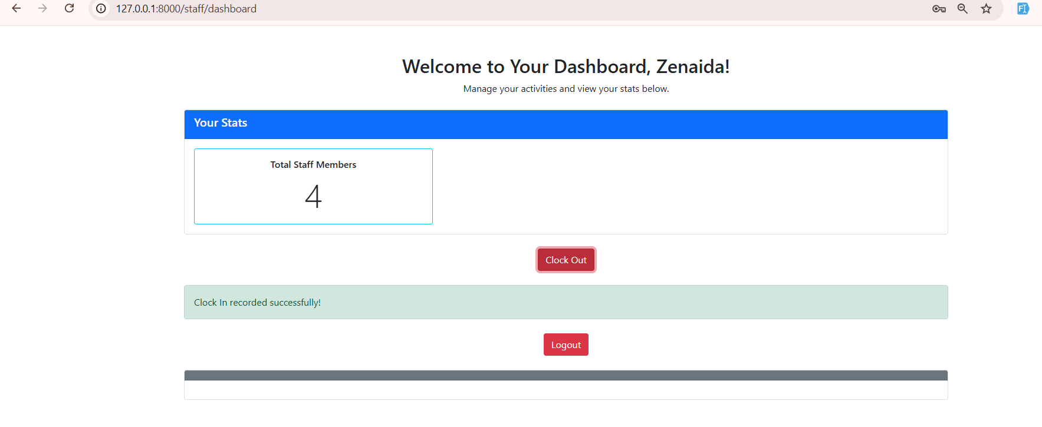

* Clock out :

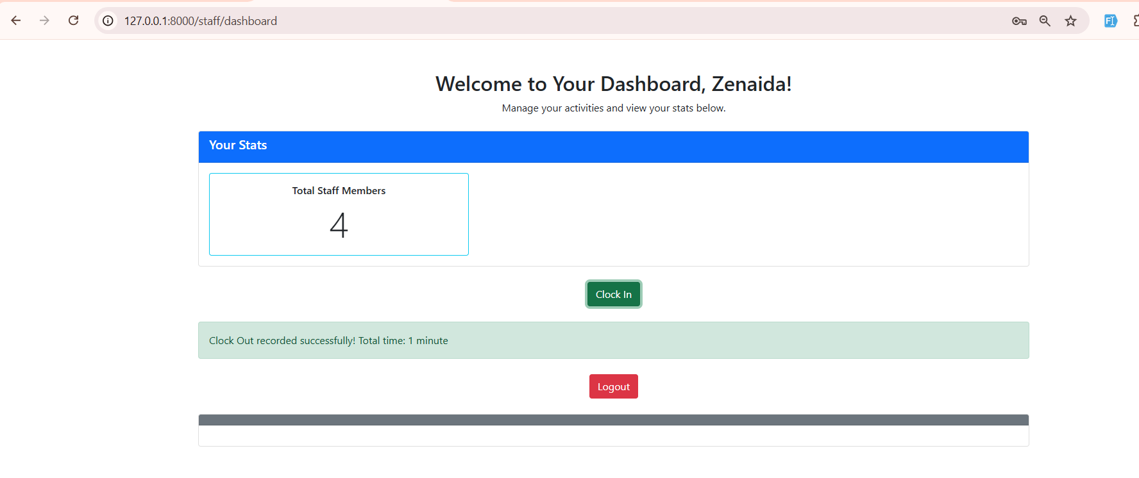

* Listi at admin side :

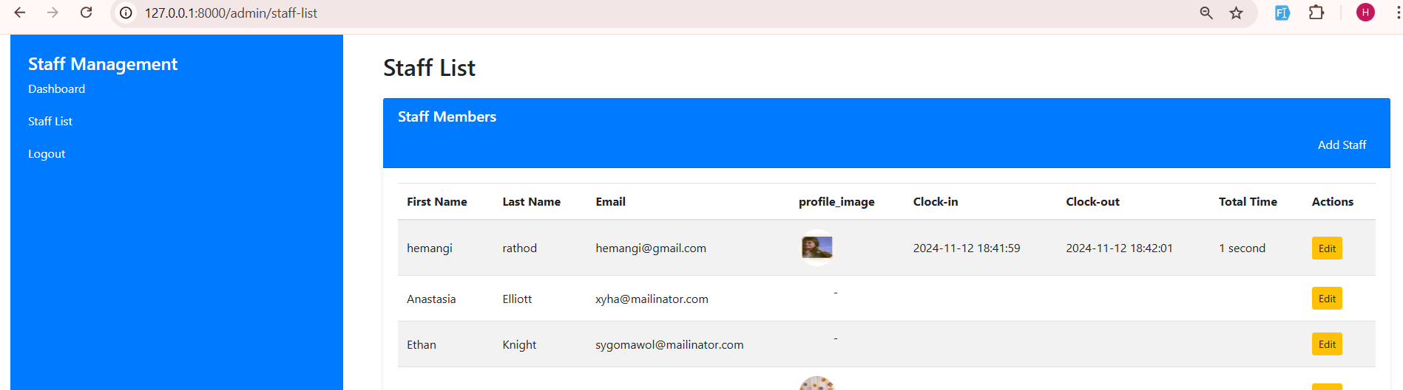

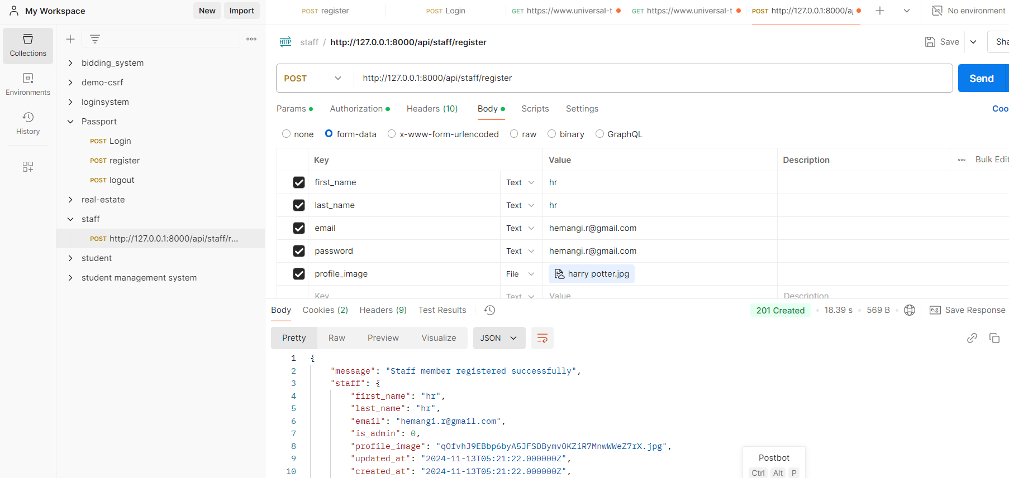

* Login api :

